**Lab 5.4**

***Note that the inner loop of this program is always executed exactly three times - once for each day of the long weekend. Modify the code so that the inner loop iterates n times, where n is a positive integer input by the user. In other words, let the user decide how many days to consider just as they choose how many students to consider. Take a screen shot of the output.***

I modified the program so that the user can decide how many days a student spent programming. Here's an example of the output:

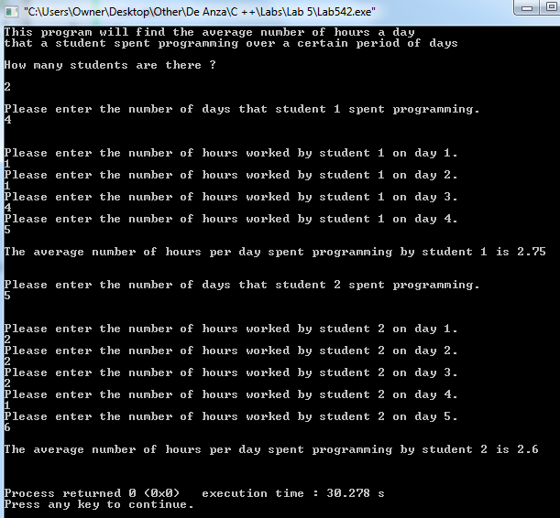

***Modify the program so that it also finds the average number of hours per day that a given student studies biology as well as programming. For each given student include two prompts, one for each subject. Have the program print out which subject the student, on average, spent the most time on. Take a screen shot of the output.***

I modified the program to do that. Here's the output:

